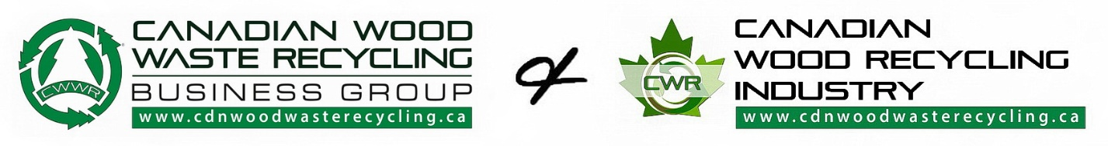

2021 Canadian Wood Recycling Industry Membership Application

Corporation Name: _____________________________________________________  Address: __________________________________________________________________  City: ______________________________ Province/State: ____________________  Postal/ZIP: _______________________ Country: ____________________________ | Authorized Name: _____________________________________________________  Title: _______________________ E-mail: ____________________________________  Web: ____________________________ Tel: ( ) ____________________________  Cell: ( ) ______________________ Note: __________________________________
Canadian Wood Recycling Industry Business Categories

Wood Waste Generator -Mobile or Stationary Wood Recycling Co. - Landfill/Transfer Station Co. - Contractor Co.
Construction Co. – Barnwood Co. - Renovation Co. - Demolition Co. - Landscape Co. - Sawmill Co. - Firewood Co.
Forestry Co. - Logging Co. - Woodlands Contractor - Lumber Mill Co. - Woodlot Owner - Reforestation Co. - Engineering Co.
Architect Co. - Oil & Gas Co. - Energy Co. - Hazardous Waste Co. - Federal - Provincial - Municipality - Regional - County Government
Equipment Mfg. - Equipment OEM Supplier - Transportation Co. - Trucking Co - Roll-off Co. - Construction Co.
Media, Publication, Journalist and or other business forte

Please circle the relevant category(s) that best identify your industry related business type activities

Canadian Wood Recycling Industry Membership Benefits

As a member of the Canadian Wood Waste Recycling Business Group, you are part of the elite Canadian and International leadership contingent building the Canadian Wood Recycling as a national to be regulated industry. Collectively we present to you the opportunity to expedite your respective business growth in the Canadian Wood recycling industry, while advancing your economic, social and environmental outcome.
Canadian Wood Waste Recycling Business Group (CWWR)
(industry membership Categories & Annual fees)

Corporate membership | Membership fee is $800.00 per annum
Approved, non-profit, association, society, institutional, academia and students can attain a Free membership

Canadian Wood Waste Recycling Business Group Annual Membership Fee

Annual Membership Fee: $800.00 Incl. Canadian. Funds.

Please complete your 2021 Canadian Wood Waste Recycling Business Group – Canadian Wood Recycling industry
membership application and email return send with selected payment. * Thank you. Jim Donaldson Founder | CEO

Our Canadian Wood Waste Recycling Business Group’s supportive industry membership payment options are as follows

A Credit card payment is accepted c/o of the Square payment system. Please contact the office (780) 239-5445
A Debit payment is accepted c/o of the Interac e-transfer to jdonaldson@cdnwoodwasterecycling.ca
A Corporate Cheque payment is only accepted c/o a Priority post or Courier to avoid lost mail by the CANADA Post sys

ADDRESS: Canadian Wood Waste Recycling Business Group.
#108 - 4301 B South Park Drive, Suite 206
Stony Plain, AB. T7Z 2A9 CANADA

Note: Upon payment receipt, a paid pdf. invoice receipt is emailed.
Payments for CWWR Membership are non-refundable. Our fiscal year is January 01 each respect year.

Authorized Name: (Print) _____________________________________________________ Title: ______________________________________

Signature: _____________________________________________________________ Date: _______________________________________

www.cdnwoodwasterecycling.ca

Thank you for your support in the building of the Canadian Wood Recycling industry

